In Class test about Networking Principals
Start time 9.30 am - - End of test 12.15 pm
What is a PAN?
A personal area network (PAN) is the interconnection of information technology devices within the range of an individual person, typically within a range of 10 meters.
What is a LAN?
A local area network (LAN) is a group of computers and associated devices that share a common communications line or wireless link to a server. Typically, a LAN encompasses computers and peripherals connected to a server within a distinct geographic area such as an office or a commercial establishment.
What is a MAN?
Metropolitan area network (MAN) is a network that interconnects users with computer resources in a geographic area or region larger than that covered by even a large local area network (LAN) but smaller than the area covered by a wide area network (WAN). The term is applied to the interconnection of networks in a city into a single larger network (which may then also offer efficient connection to a wide area network).
What is a WAN?
A wide area network (WAN) is a geographically distributed private telecommunications network that interconnects multiple local area networks (LANs). In an enterprise, a WAN may consist of connections to a company's headquarters, branch offices, colocation facilities, cloud services and other facilities. Typically, a router or other multifunction device is used to connect a LAN to a WAN.

What is the optimum range for Bluetooth?
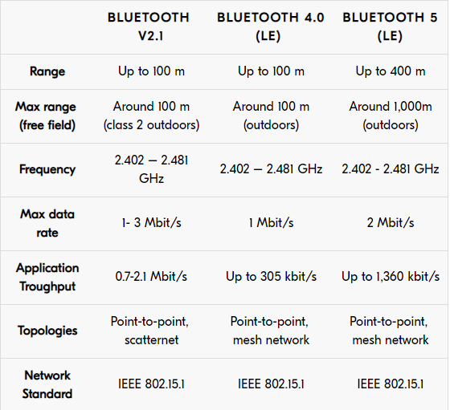
Explain the difference between infra red and Bluetooth?
Infrared technology is what most TV remotes use. The distance an infrared signal can travel varies based on the strength of the remote, but is usually less than 50 feet for household electronics. In order for an infrared signal to be detected, there must be a direct line of sight between the transmitter (remote) and the receiver (TV). If there is a wall or large object between them, the signal will not pass through it.
Bluetooth, on the other hand, uses a radio frequency, which allows transmission through walls and other objects. The standard range of a Class 3 Bluetooth device is about 30 ft., which makes it ideal for syncing PDAs with computers, using wireless cell phone headsets, and enabling hands-free cell phone use inside Bluetooth-enabled automobiles. Because Bluetooth technology is based on a standard 2.4 GHz frequency, different Bluetooth devices can typically communicate with each other, regardless of the manufacturer. Most infrared devices only work with proprietary equipment.

What is IEEE 802.15?
802.15 is a communications specification that was approved in early 2002 by the Institute of Electrical and Electronics Engineers Standards Association (IEEE-SA) for wireless personal area networks (WPANs). The initial version, 802.15.1, was adapted from the Bluetooth specification and is fully compatible with Bluetooth 1.1.
What is IEEE 802.11?
802.11 is an evolving family of specifications for wireless local area networks (WLANs) developed by a working group of the Institute of Electrical and Electronics Engineers (IEEE). All the 802.11 specifications use the Ethernet protocol and Carrier Sense Multiple Access with Collision Avoidance (CSMA/CA) for path sharing.
What is a co-axel cable used for?
The coaxial cable is a copper-based wire cable. It is composed of four separate layers. The centre of the cable has a thin wire conductor. Surrounding the copper wire is a layer of plastic insulation. On top of this layer is a wire mesh providing another layer of insulation and a shield from outside interference. The final and outermost layer of the coaxial cable is another rubber layer, providing the last means of insulation. Each end of the cable has a thin layer of copper that can be screwed into the receiving electronics. The coaxial cable is primarily used for audio and visual purposes. Modern homes are typically equipped with at least one coaxial cable outlet in each room. This is because cable companies primarily use coaxial cables to bring cable television to their customers. Coaxial cables can be connected from the wall outlet directly to the customer’s television or cable box. A second use for coaxial cables is connecting VCRs to a television. A final use of the coaxial cable is attaching a personal antenna to a television set or digital converter box.
What is a twisted pair cable used for?
A twisted-pair cable is a cable made by intertwining two separate insulated wires. There are two twisted pair types: shielded and unshielded. This type of cable is widely used in different kinds of data and voice infrastructures.
What is a shielded twisted pair cable used for?
A STP (Shielded Twisted Pair) cable has a fine wire mesh surrounding the wires to protect the transmission and a UTP (Unshielded Twisted Pair) cable does not. Shielded cable is used in older telephone networks, as well as network and data communications to reduce outside interference.
A group of computers are connected in multi-storey building. This would be considered a:

A: WAN
B: MAN
C: LAN
D: none of the above

A group of computers in the south side of a city are connected to another group of computers downtown. This would be considered a:
A: WAN
B: MAN
C: LAN
D: LAN and MAN

A group of computers in Denver connect to another group of computers in San Francisco. This would be considered a:
A: WAN
B: MAN
C: LAN
D: none of the above

A LAN is best described as a network that:
A: is considered to only a few buildings and maintain by long distance carriers.
B: is confined to a single building
C: Spans multiple cities and possibly multiple countries.
D: Spans a single city and uses local telephone company facilities foe connectivity.

A WAN is best described as a network that:
A: is confined to only a few buildings and maintained by long distance carriers
B: is confined to a single building or single floor of a building.
C: Spans multiple cities and possible multiple countries.
D: spans a single city and uses local telephone company facilities for connectivity.

A MAN is best described as a network that:
A; is connected to only a few buildings and maintained by long distance carriers.
B: is confined to a single building or single floor of a building.
C: Spans multiple cities and possibly multiple countries.
D: Spans a single city and uses local telephone company faculties for connectivity.

What is the Ping command used for?
Ping is a utility first developed by Michael Muss in 1983 that is used to verify whether or not a network data packet is capable of being distributed to an address without errors. The ping utility is commonly used to check for network errors.
What is the command line? Give one example of it`s use.
The command line is an interface for typing commands directly to a computer's operating system. The command line is commonly used in networking, where the network engineer will use the command line to use ping or trace packets or do any other networking tasks.
Please explain:
What is a Switch?
On a network, a switch is a hardware device that filters and forwards network packets, but often not capable of much more.
What is a Smart Switch?
What is a Hub?
A hub, also called a network hub, is a common connection point for devices in a network. Hubs are devices commonly used to connect segments of a LAN. The hub contains multiple ports. When a packet arrives at one port, it is copied to the other ports so that all segments of the LAN can see all packets.

What is a Router?
A router is a device that analyses the contents of data packets transmitted within a network or to another network. Routers determine whether the source and destination are on the same network or whether data must be transferred from one network type to another, which requires encapsulating the data packet with routing protocol header information for the new network type.

What is a Server?
A server is a computer, a device or a program thsat is dedicated to managing network resources. Servers are often referred to as dedicated because they carry out hardly any other tasks apart from their server tasks.
There are a number of categories of servers, including print servers, file servers, network servers and database servers.
In theory, whenever computers share resources with client machines they are considered servers.

What is a Peer to Peer Network?
In its simplest form, a peer-to-peer (P2P) network is created when two or more PCs are connected and share resources without going through a separate server computer. A P2P network can be an ad hoc connection—a couple of computers connected via a Universal Serial Bus to transfer files. A P2P network also can be a permanent infrastructure that links a half-dozen computers in a small office over copper wires.
What is a Client Server Network?
A computer network in which one centralized, powerful computer (called the server) is a hub to which many less powerful personal computers or workstations (called clients) are connected. The clients run programs and access data that are stored on the server.
What is a protocol?
A protocol is a set of rules and guidelines for communicating data. Rules are defined for each step and process during communication between two or more computers. Networks have to follow these rules to successfully transmit data.

What is DNS?
The DNS is the phonebook of the internet. Humans access information online through domain names, like espn.com or nytimes.com. Web browsers interact through IP addresses. DNS translates domain names to IP so browsers can load internet resources.
Please give the address plus a screen shoot of the website given below.
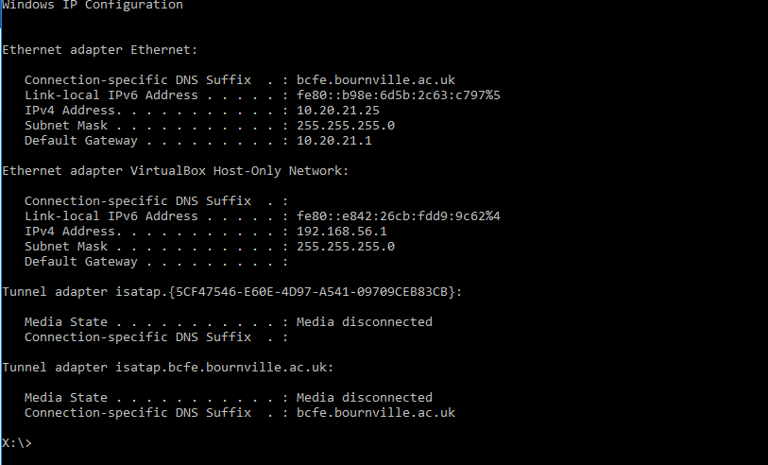
What is CSMA/CD?
Carrier Sense Multiple Access and Collision Detection
What is CSMA/CA?
Carrier Sense Multiple Access and Collision Avoidance
Please explain the role of both CSMA/CD and CSMA DA in networking.
CSMA/CA (Carrier Sense Multiple Access/Collision Avoidance) is a protocol for carrier transmission in 802.11 networks. Unlike CSMA/CD (Carrier Sense Multiple Access/Collision Detect) which deals with transmissions after a collision has occurred, CSMA/CA acts to prevent collisions before they happen.

HTML
Hypertext Markup Language, a standardized system for tagging text files to achieve font, colour, graphic, and hyperlink effects on World Wide Web pages.
HTTP
HTTP means HyperText Transfer Protocol. HTTP is the underlying protocol used by the World Wide Web and this protocol defines how messages are formatted and transmitted, and what actions Web servers and browsers should take in response to various commands.
URL
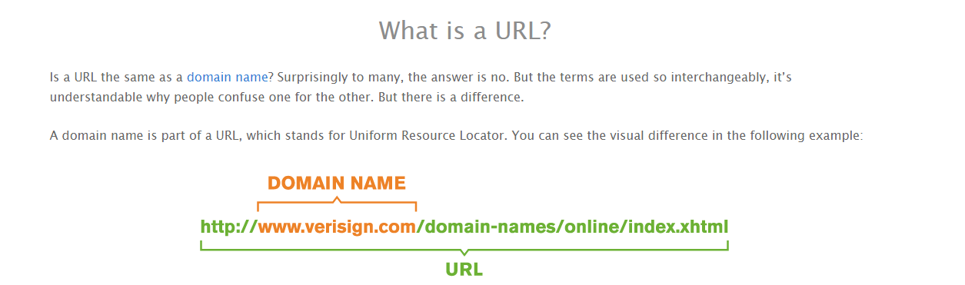
ADSL
ADSL stands for asymmetric digital subscriber line, a broadband connection that uses home telephone lines to transfer data from your provider to your home. As telephone giant BT owns the UK's landline infrastructure, you'll likely be using their phone line for your connection.
Bandwidth
Bandwidth refers to the maximum amount of data that can be transmitted via an internet provider over a certain period of time.
Gateway
A gateway is a hardware device that acts as a "gate" between two networks. It may be a router, firewall, server, or other device that enables traffic to flow in and out of the network. While a gateway protects the nodes within network, it also a node itself.
What is a domain name? Please include an example.
The part of a network address that identifies it as belonging to a particular domain. Example: www.Google.co.uk
What is a Web Hosting service? Please include two providers.
Web hosting is a service that allows organizations and individuals to post a website or web page onto the Internet. A web host, or web hosting service provider, is a business that provides the technologies and services needed for the website or webpage to be viewed in the Internet.
Example: Dream Host and Site ground
Task-1 Assignment 1.2 From End to End
Tasks
- Identify and describe four types of communication devices, use images where appropriate.
Mobile phone – send images, texts, email, voice call and voice chat
Laptop - send images, texts, email, voice call and voice chat
WI-Fi – allows users to send information over a local network
Bluetooth Devices – allows users to send data without needing a constant internet connection
Infra-Red Devices – allows you to control devices (e.g. tv remote)
- Describe what data elements are and why they are important.
This is important because even small changes to data in a network can have a big effect such as stopping a network working compactly. Encapsulation: Encapsulation is defined as the packing of data/functions into a signal component. Examples of this include frames, packets and addresses.

END OF TEST
Please hand-in a printed copy and upload to Moodle an electronic copy.

